# Logo Description automatically generated THE FIRST HAM SWAP OF THE YEAR IS COMING!

7TH ANNUAL

LOOMIS

HAMFEST

**Join the Sierra Foothills Amateur Radio Club for HAMFEST 2023!**

Get your gear, grab your wallet, and get ready for a super swap.  
We’ll have coffee and donuts, awesome prizes,  
Elmer tours, a test table, presentations on getting started with Vara Chat (@ 0800), an intro to 3D printing (@ 0900), and so much more.  
**More information can be found @** **hamfest.w6ek.org**  
Sellers need to bring their own tables, chairs, pop-ups, generators (no shore power available)  
No equipment will be provided.

Where  
Historic Loomis Train Depot  
5775 Horseshoe Bar Rd, Loomis

When  
Saturday, March 18, 2023  
0700 to 1100 Hours

**FREE ADMISSION  
AND PARKING**

TALK IN FREQUENCY **146.535**

**SELLERS $10**Setup at 0600

**PRIZES INCLUDE**

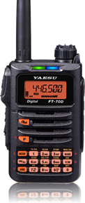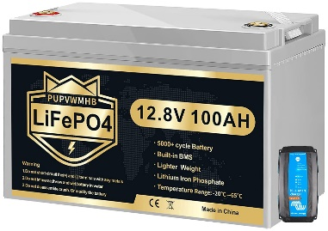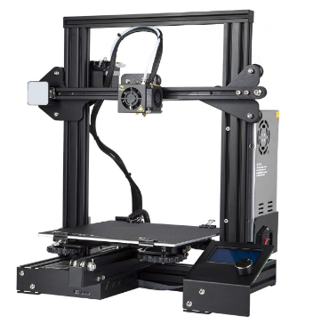

Yaesu FT-70DR & RT Systems Programming Kit

Gift Cards

PUPVWMHB 12V 100Ah LiFePO4 Battery w/ 100A BMS &  
Victron Energy Blue Smart IP65 12-Volt 15-amp Battery Charge

Creality Ender 3  
Neo 3D Printer

**SUPPORTERS**

****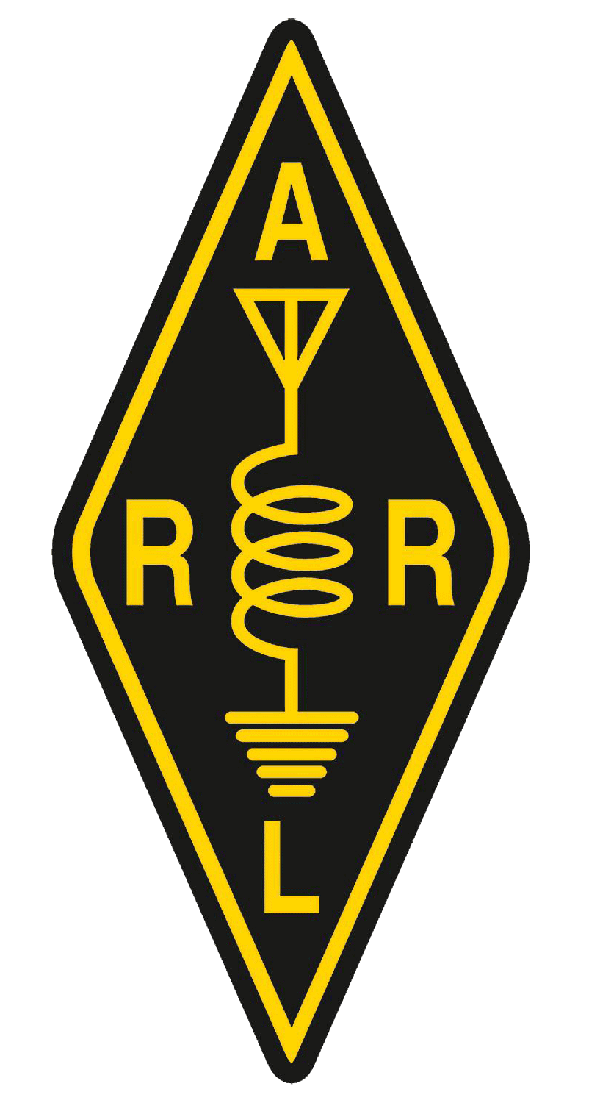

**Special thanks to:**Brian Gohl **(AI6US)**Jeff Morgan **(KM6RGO)**Aaron Bond **(W1ATB)  
for your donations.**